**Task 1-GEMINI**

**CSS** (Cascading Style Sheets) is a programming language used to style HTML elements. It controls the appearance of web pages, including layout, colors, fonts, and animations. By separating the content (HTML) from the presentation (CSS), it makes web development more efficient, maintainable, and reusable.

**Role of CSS in Web Development**

* **Styling:** CSS defines the visual appearance of web pages, making them visually appealing and user-friendly.
* **Layout:** It controls the arrangement of elements on a page, ensuring a consistent and responsive design.
* **Responsiveness:** CSS allows for creating websites that adapt to different screen sizes, making them accessible on various devices.
* **Maintainability:** By separating content from presentation, CSS makes it easier to update and maintain websites.

### Creating a Simple HTML Document with CSS

**HTML Document (index.html):**

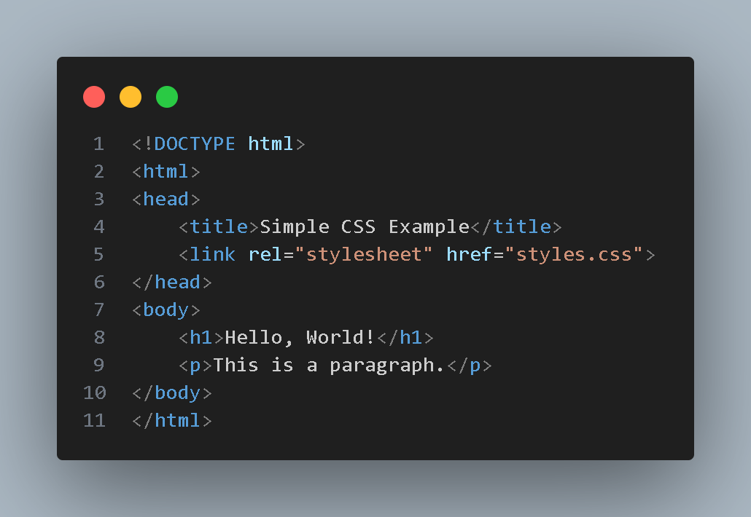

**CSS Stylesheet (styles.css):**

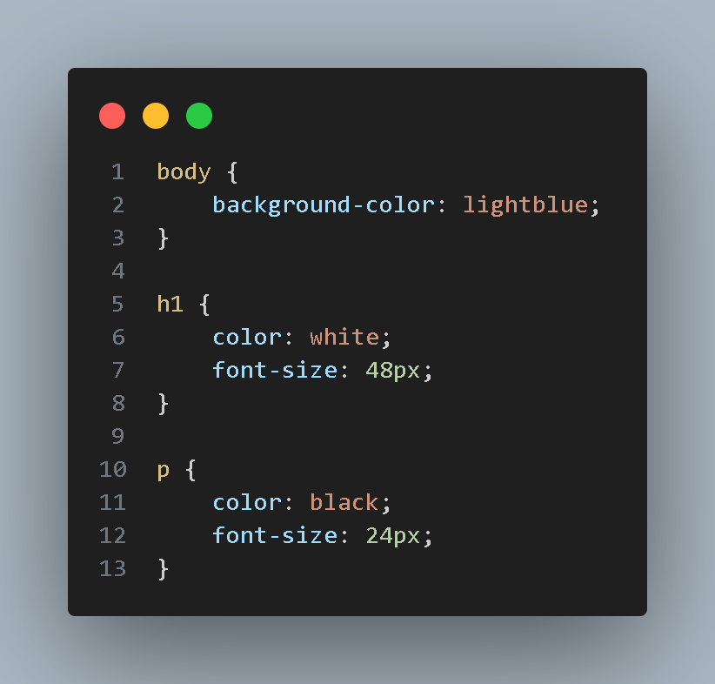

**Explanation of CSS Code**

* **body { background-color: lightblue; }:**
  + Targets the <body> element of the HTML document.
  + Sets the background color of the entire page to lightblue.
* **h1 { color: white; font-size: 48px; }:**
  + Targets all elements with the tag <h1> (the heading).
  + Sets the text color of the heading to white.
  + Sets the font size of the heading to 48 pixels.
* **p { color: black; font-size: 24px; }:**
  + Targets all elements with the tag <p> (the paragraph).
  + Sets the text color of the paragraph to black.
  + Sets the font size of the paragraph to 24 pixels.

**Result :**

